Atilla Genc

Homework 6: Follow the instruction in the below link and setup a Standalone environment: https://www.digitalocean.com/community/tutorials/how-to-set-up-a-masterless-puppet-environment-on-ubuntu-14-04

Step 1 — Creating a Git Repository

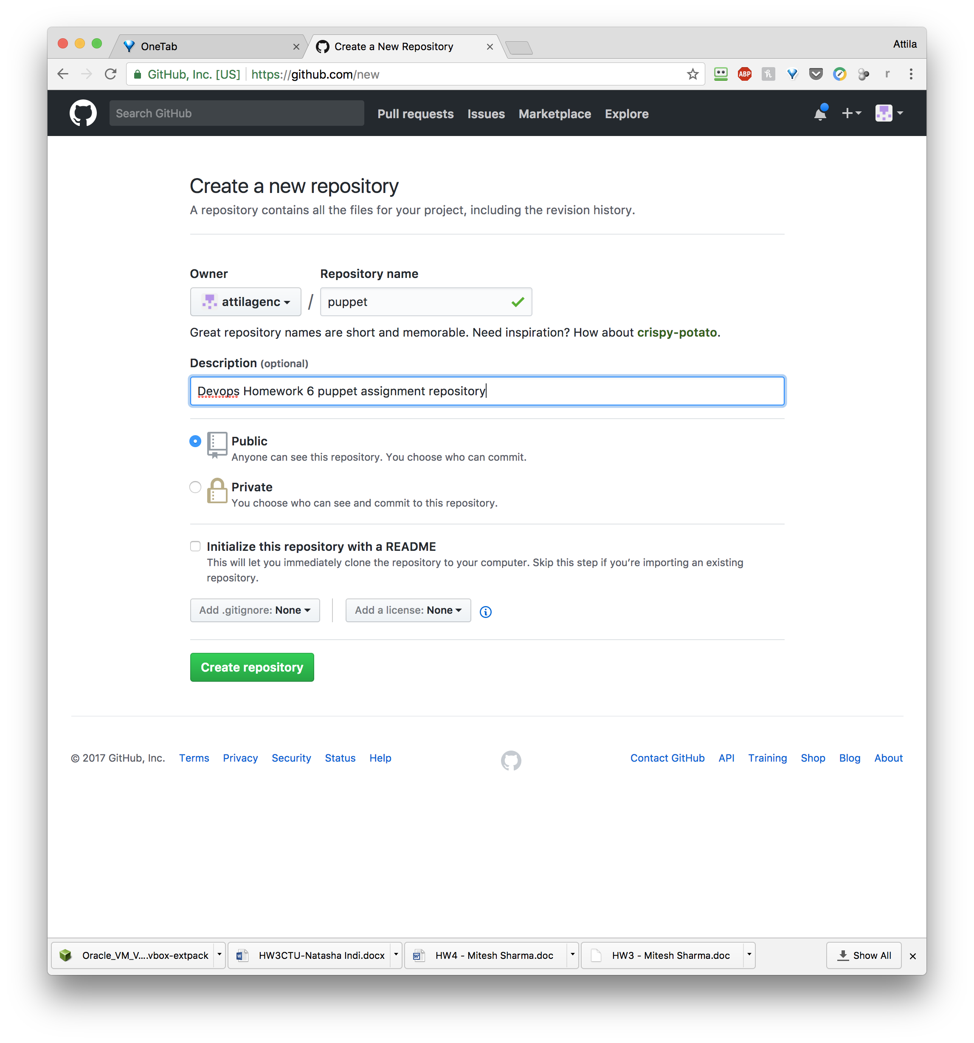

Step 2 — Adding an SSH Key to Git Labs

ssh-keygen -t rsa

cat ~/.ssh/id_rsa.pub

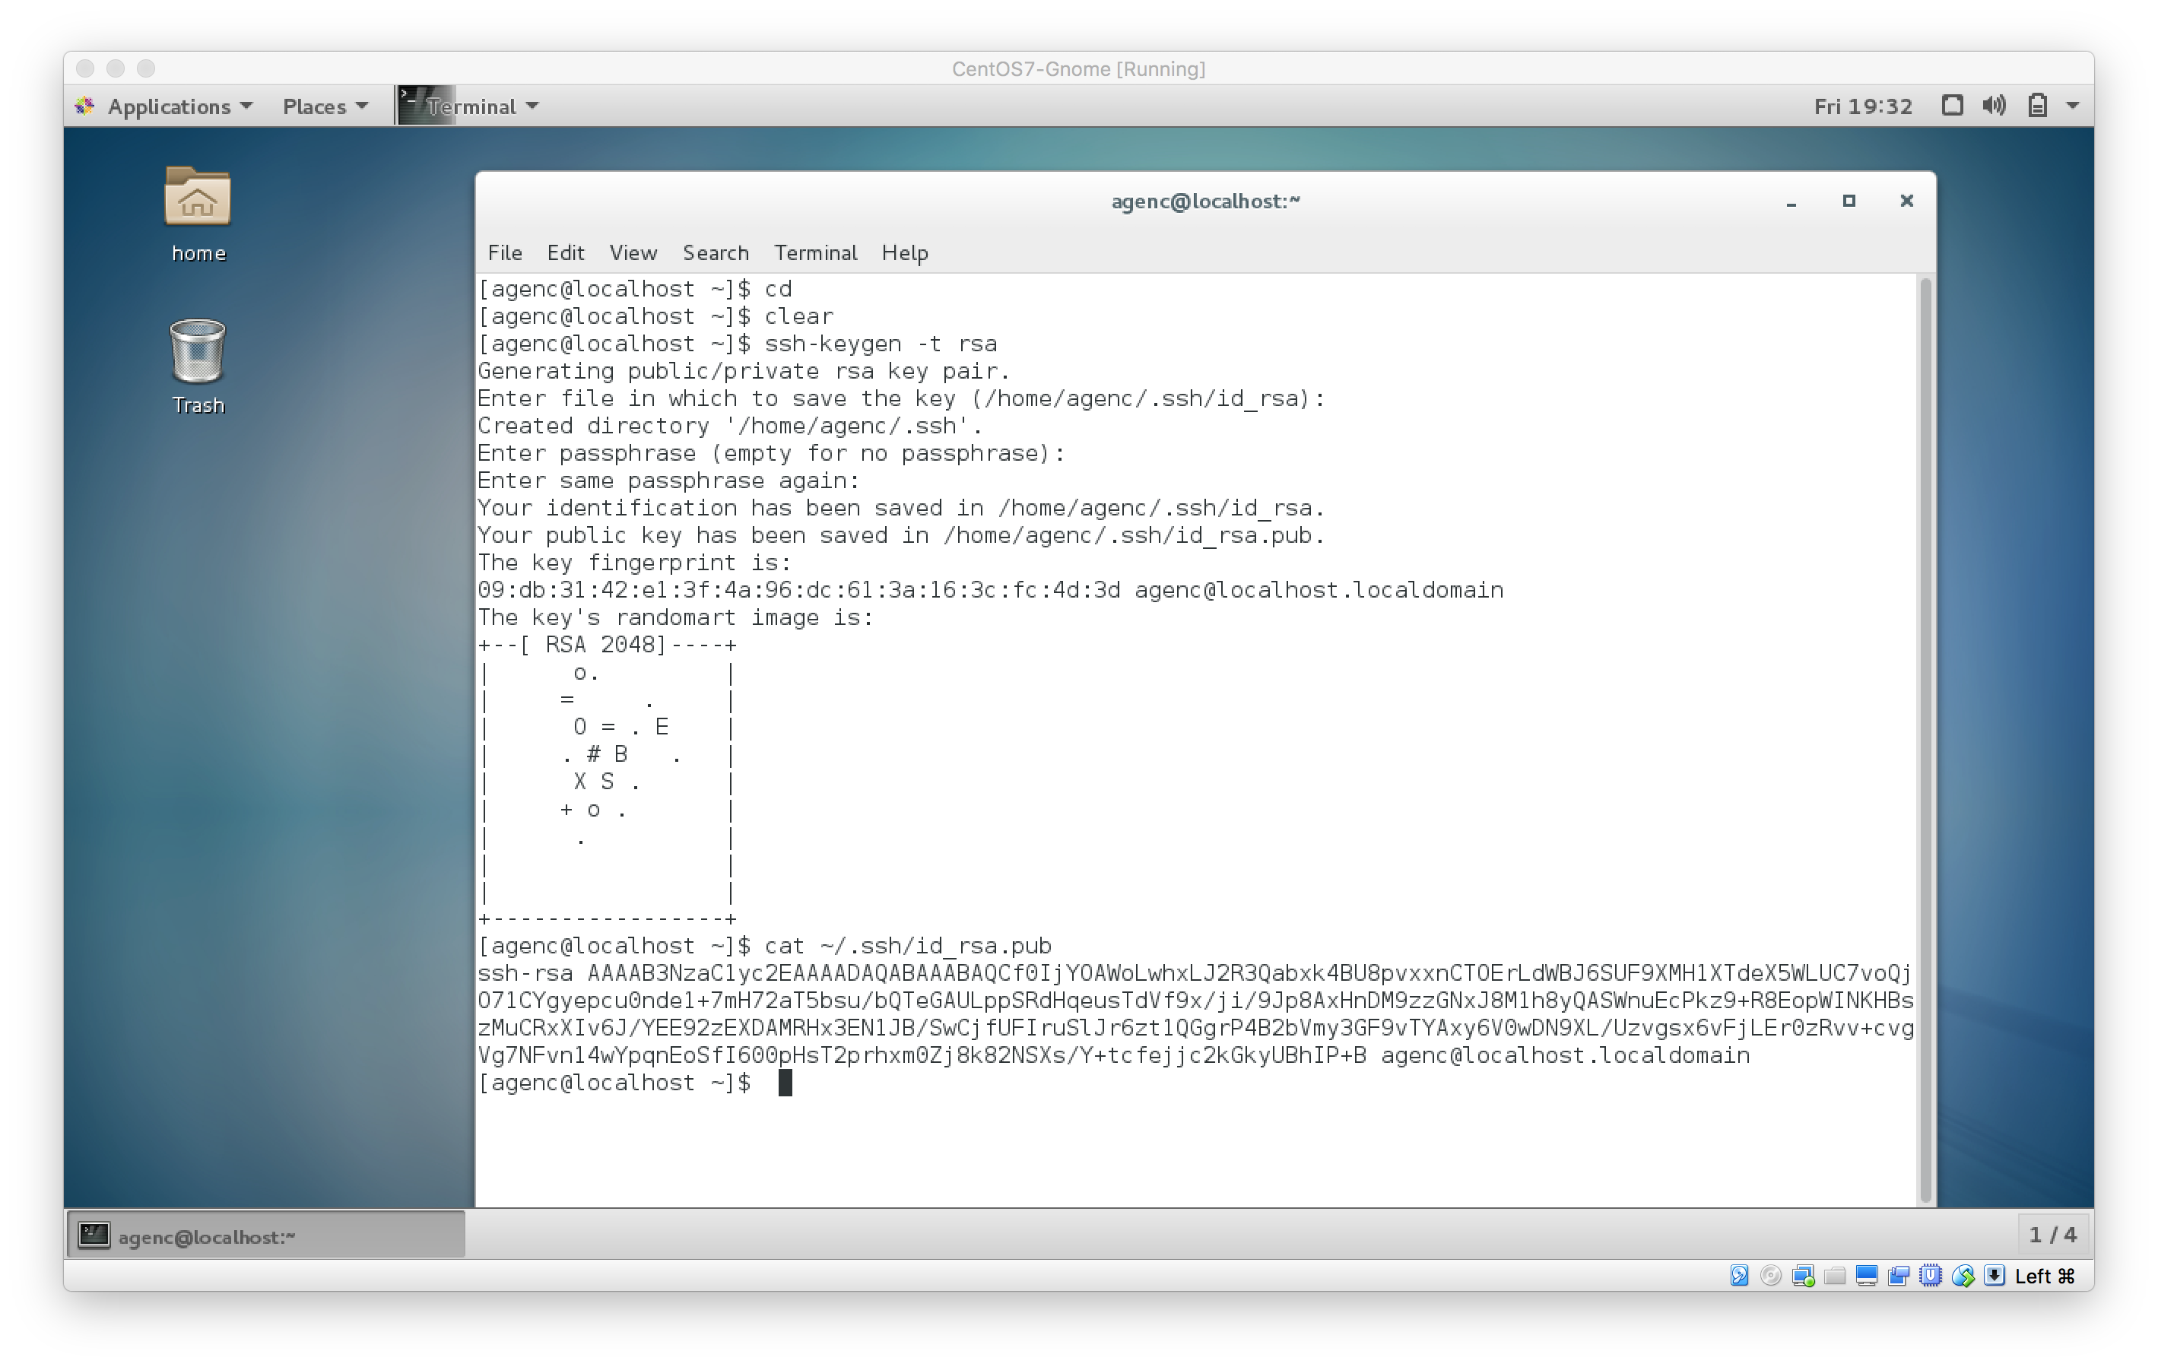

Now, on your Git Labs Dashboard page, click on the **Profile settings** icon on the top bar, second from the right. In the left menu, click **SSH Keys**, then click the green **Add an SSH Key** button. In the **Title**, field add a description of the key (like "Root Puppet Key"), and paste your public key into the **Key** field. Finally, click **Add key**.

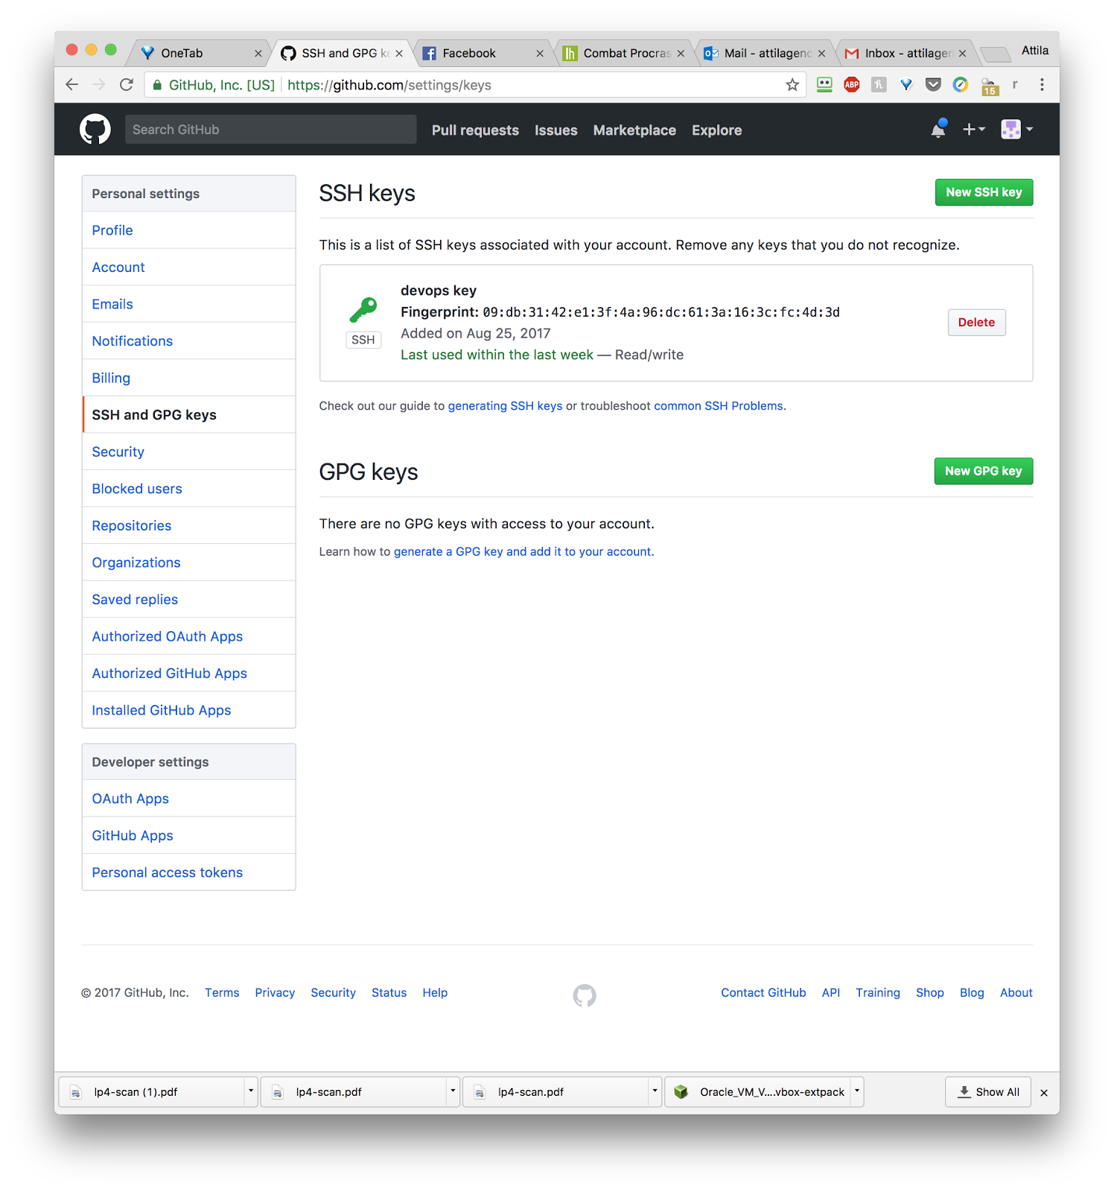

Step 3 — Installing Puppet and Git

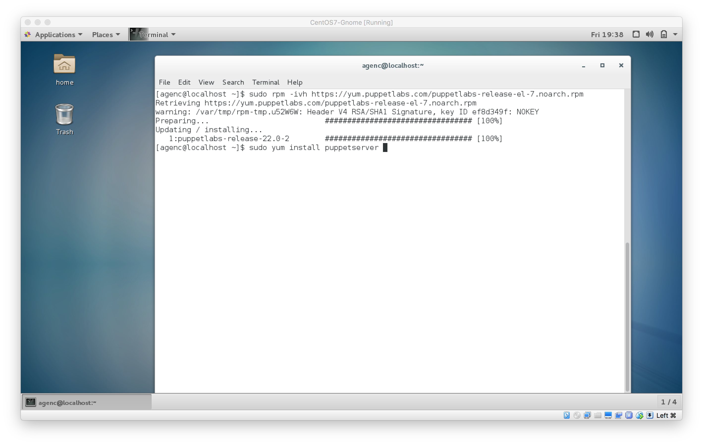

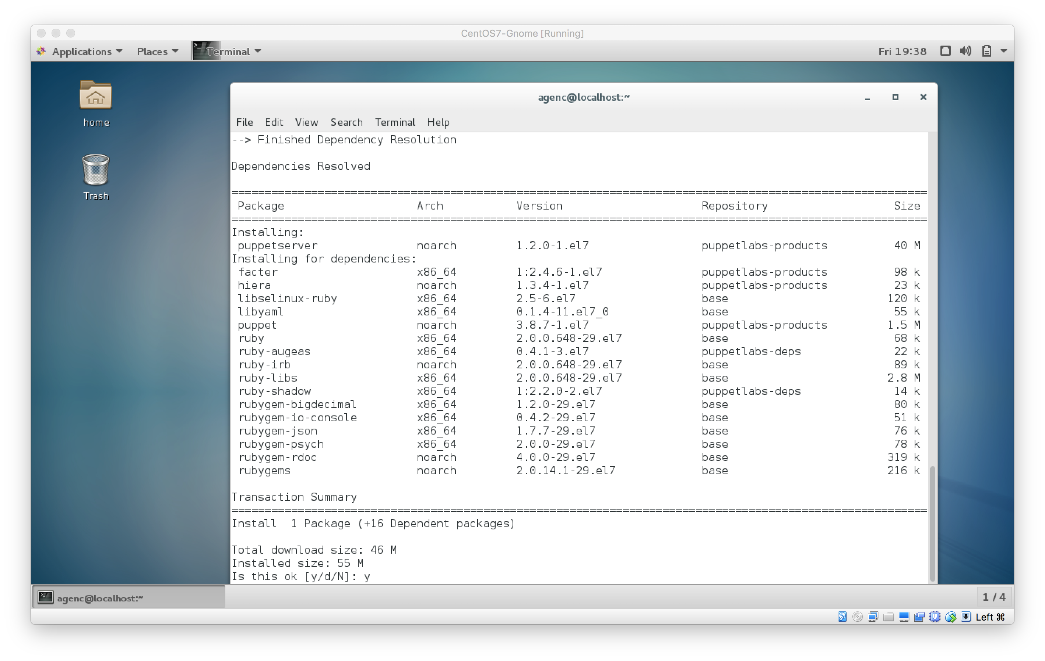

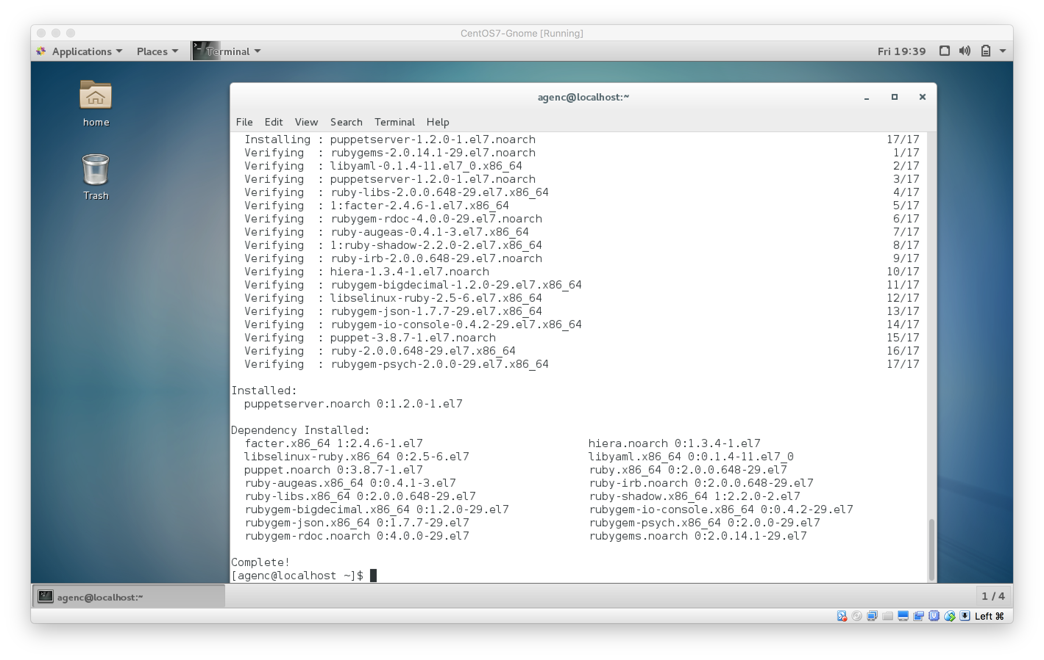

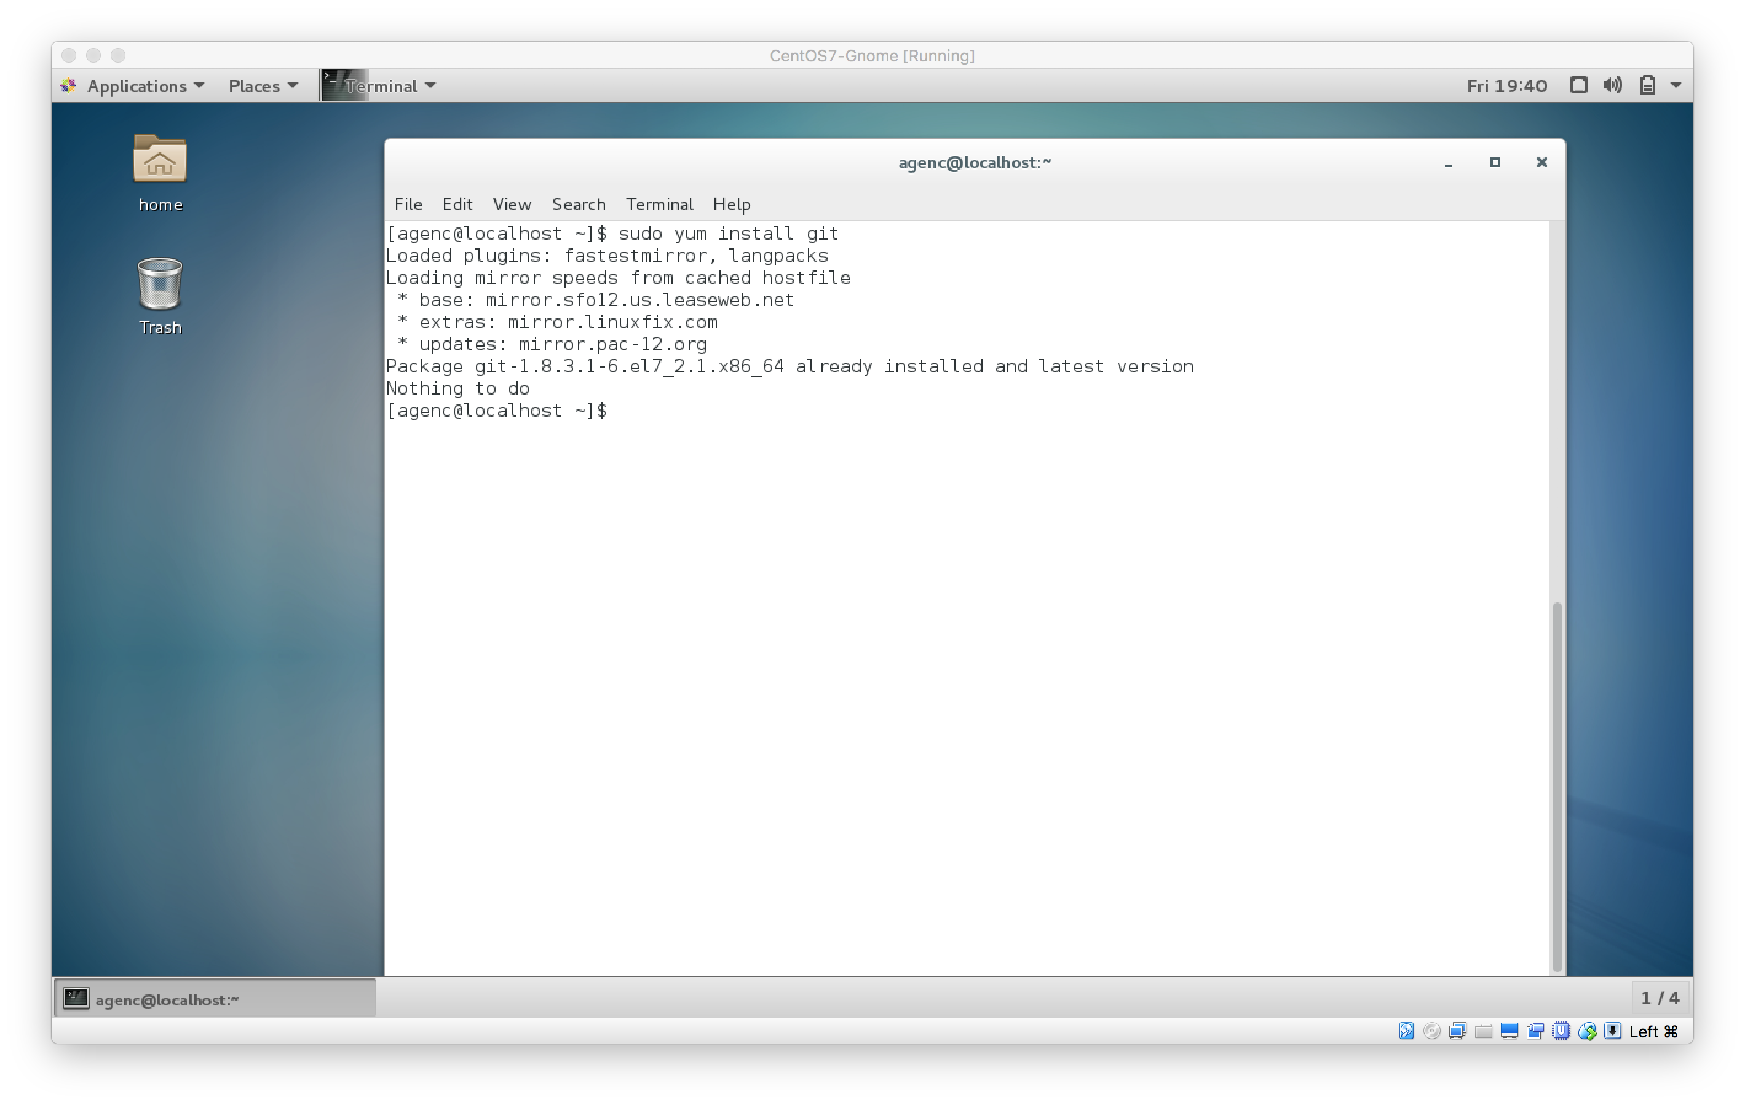

Step 4 — Pushing the Initial Puppet Configuration

First, move to the /etc/puppet directory, where the configuration files live.

* cd /etc/puppet

Initialize a git repository here.

* git init

Add everything in the current directory.

* git add .

Commit these changes with a descriptive comment.

* git commit -m "Initial commit of Puppet files"

Add the Git project we created earlier as origin using the SSH URL you copied in Step 1.

* git remote add origin git@your_server_ip:username/puppet.git

And finally, push the changes.

* git push -u origin master

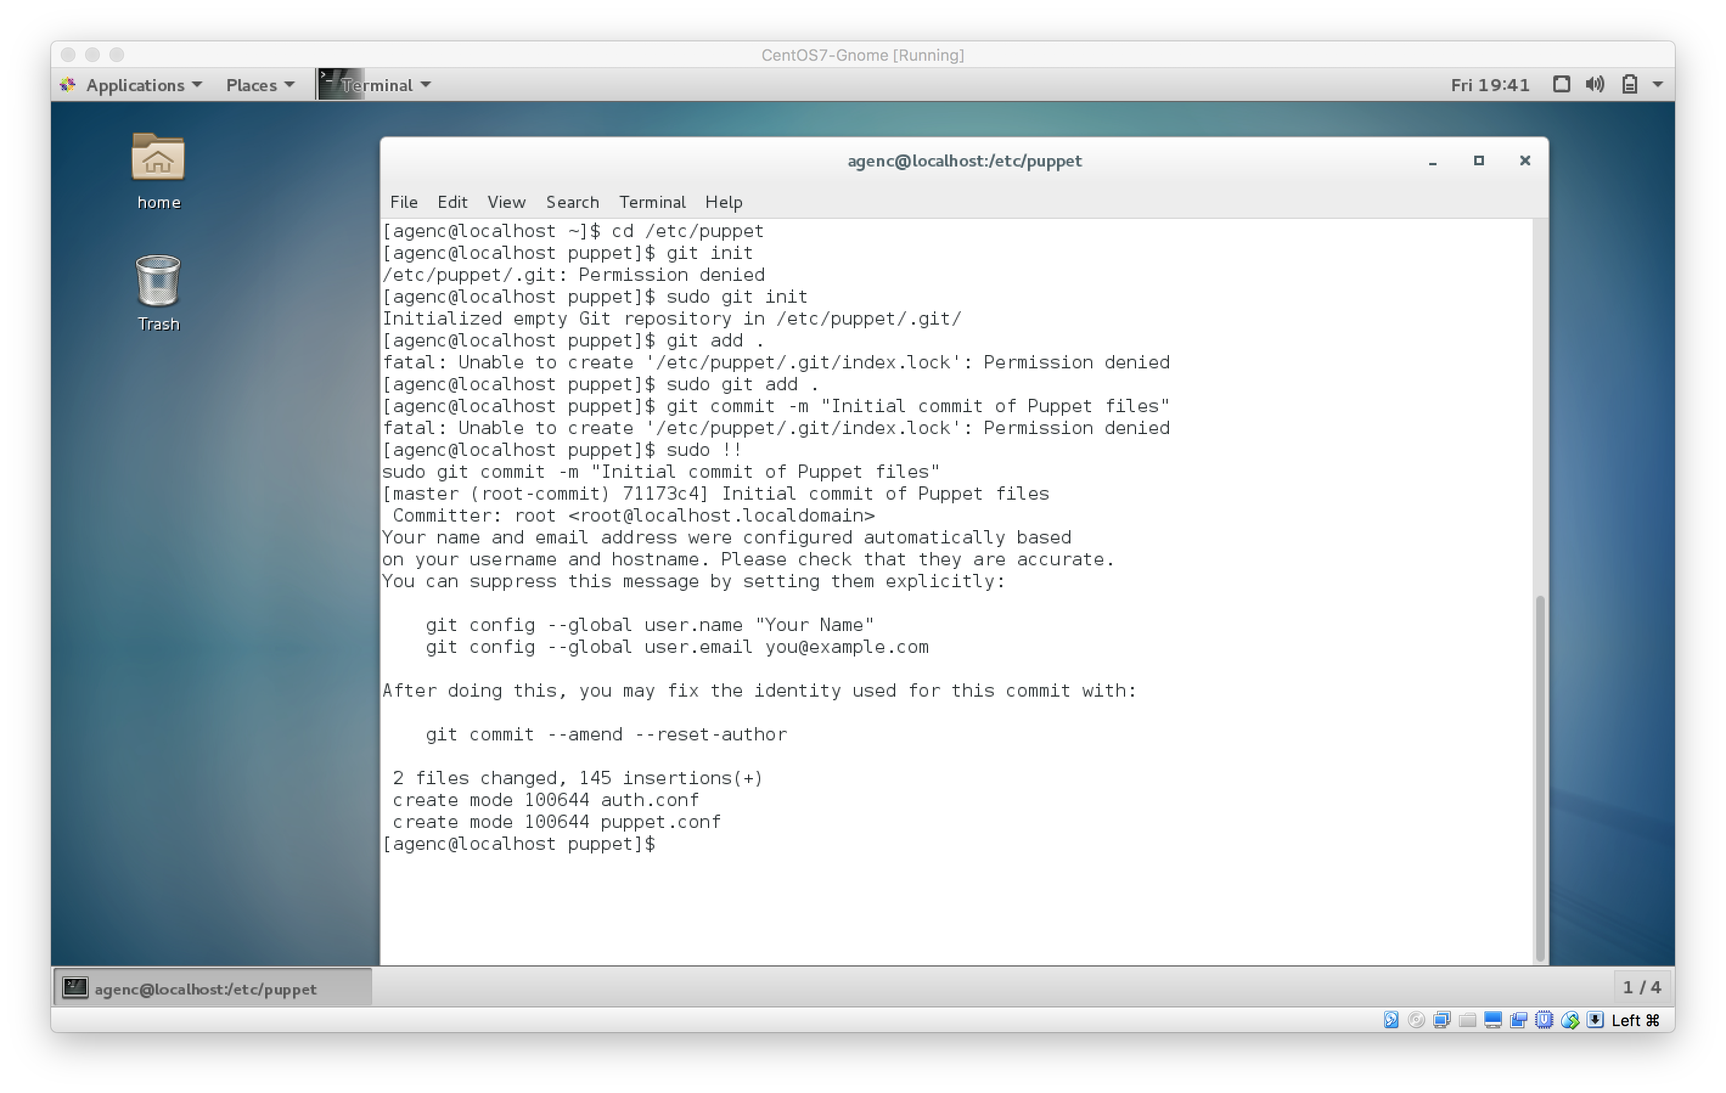

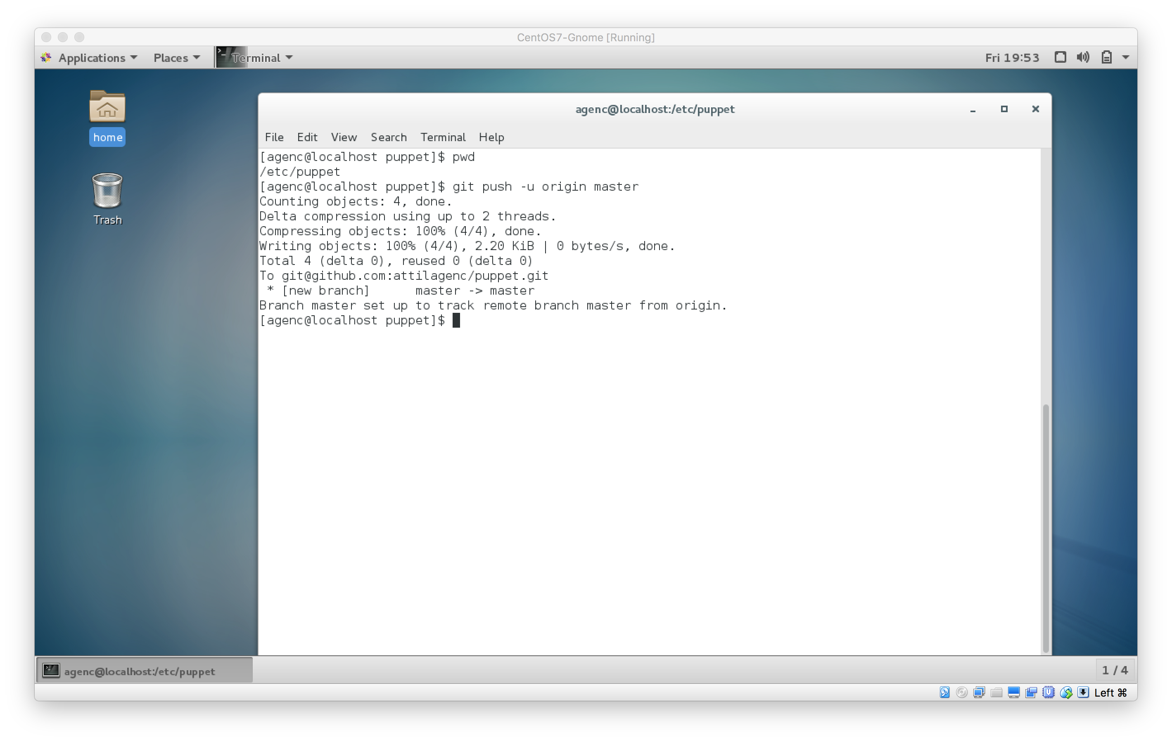

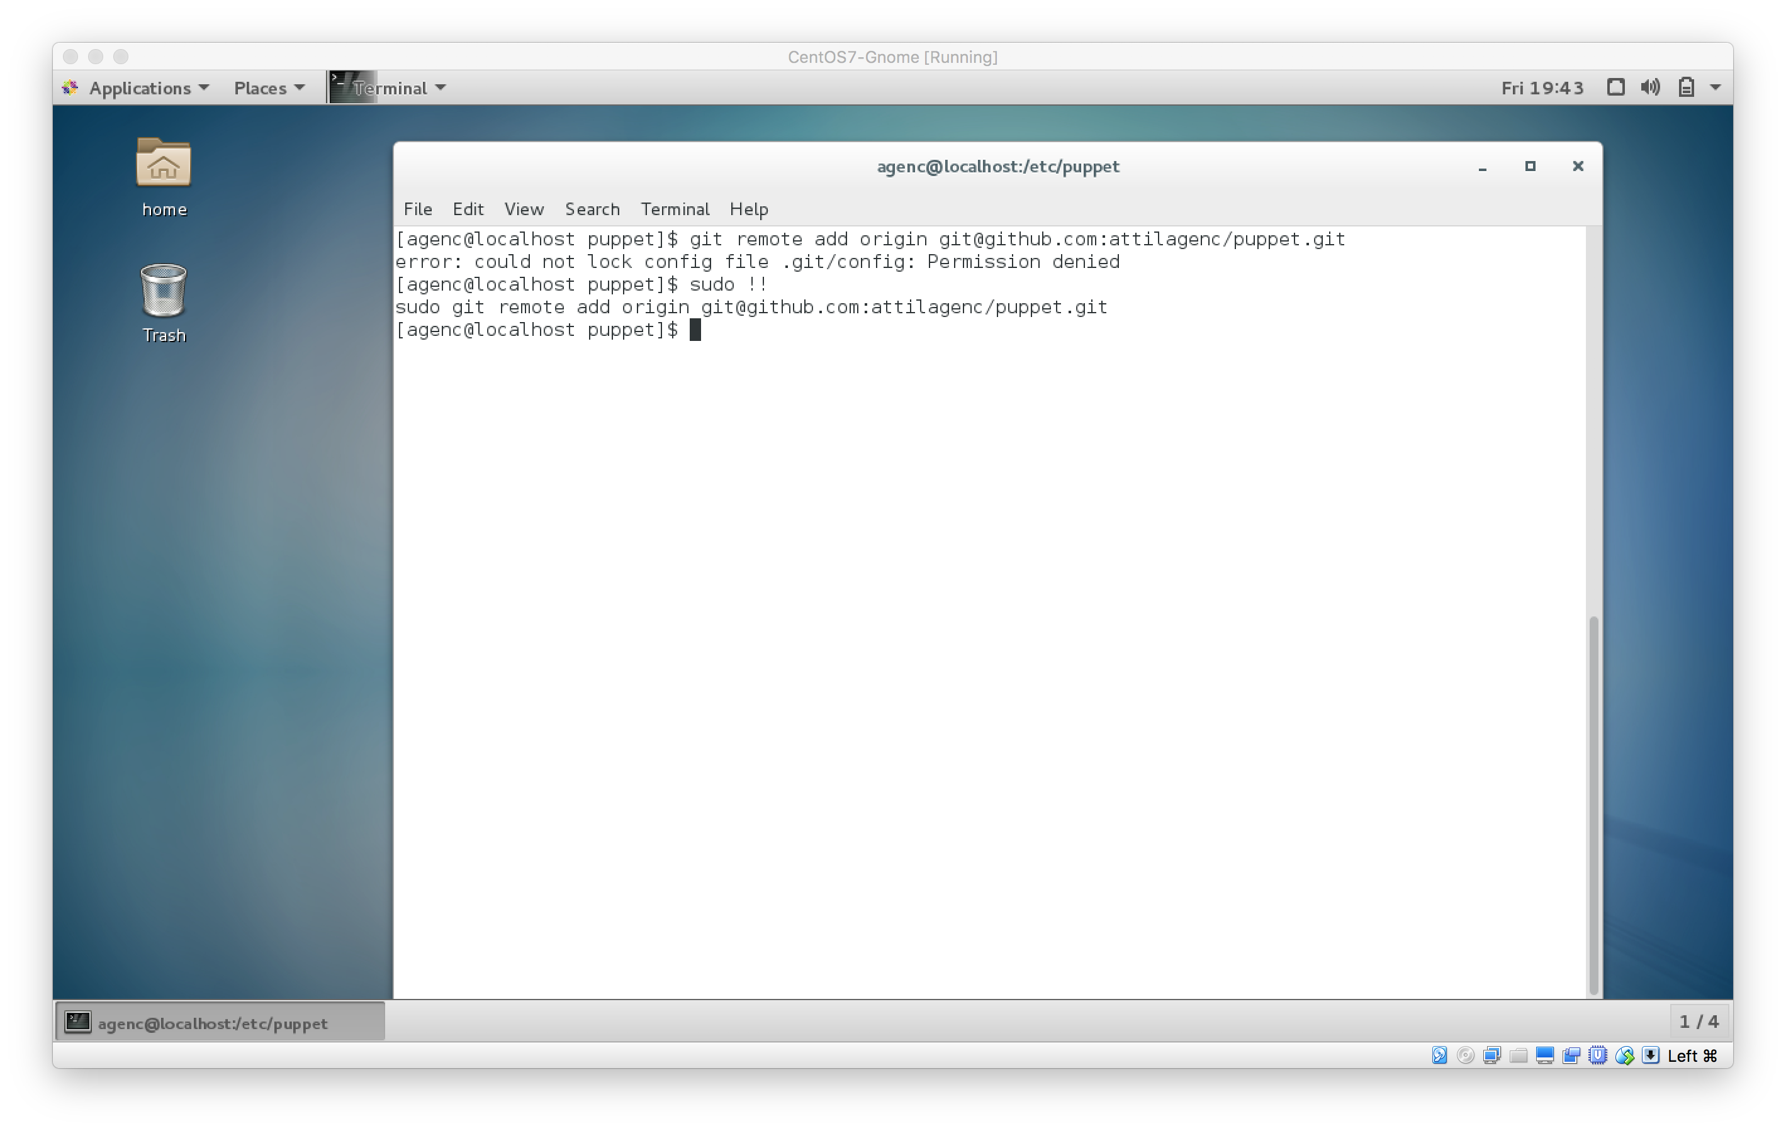

Step 5 — Cleaning Up Puppet's Configuration

Now that Puppet is installed, we can put everything together. At this point, you can log out as root and instead log in as the sudo non-root user you created during the prerequisites. It isn't good practice to operate as the root user unless absolutely necessary.

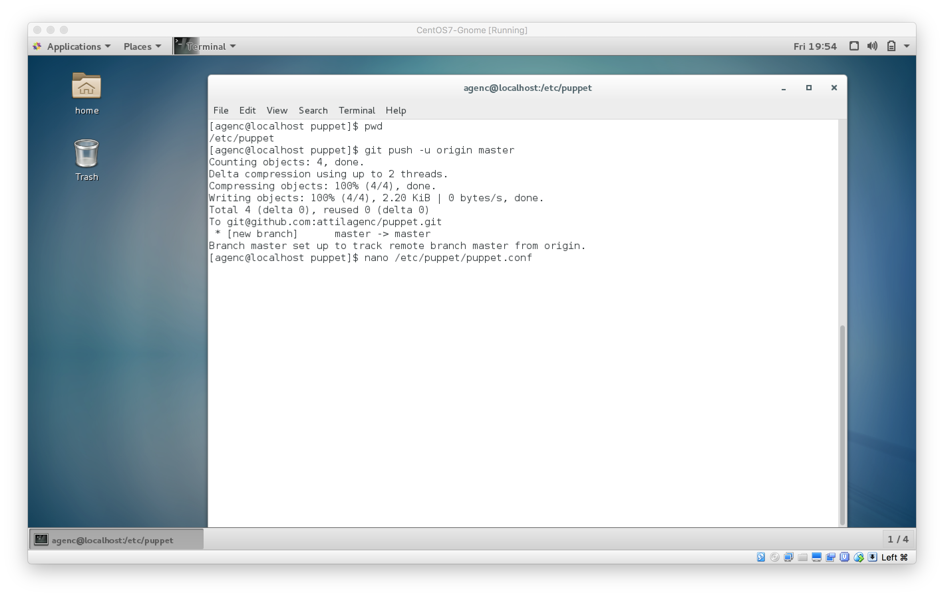

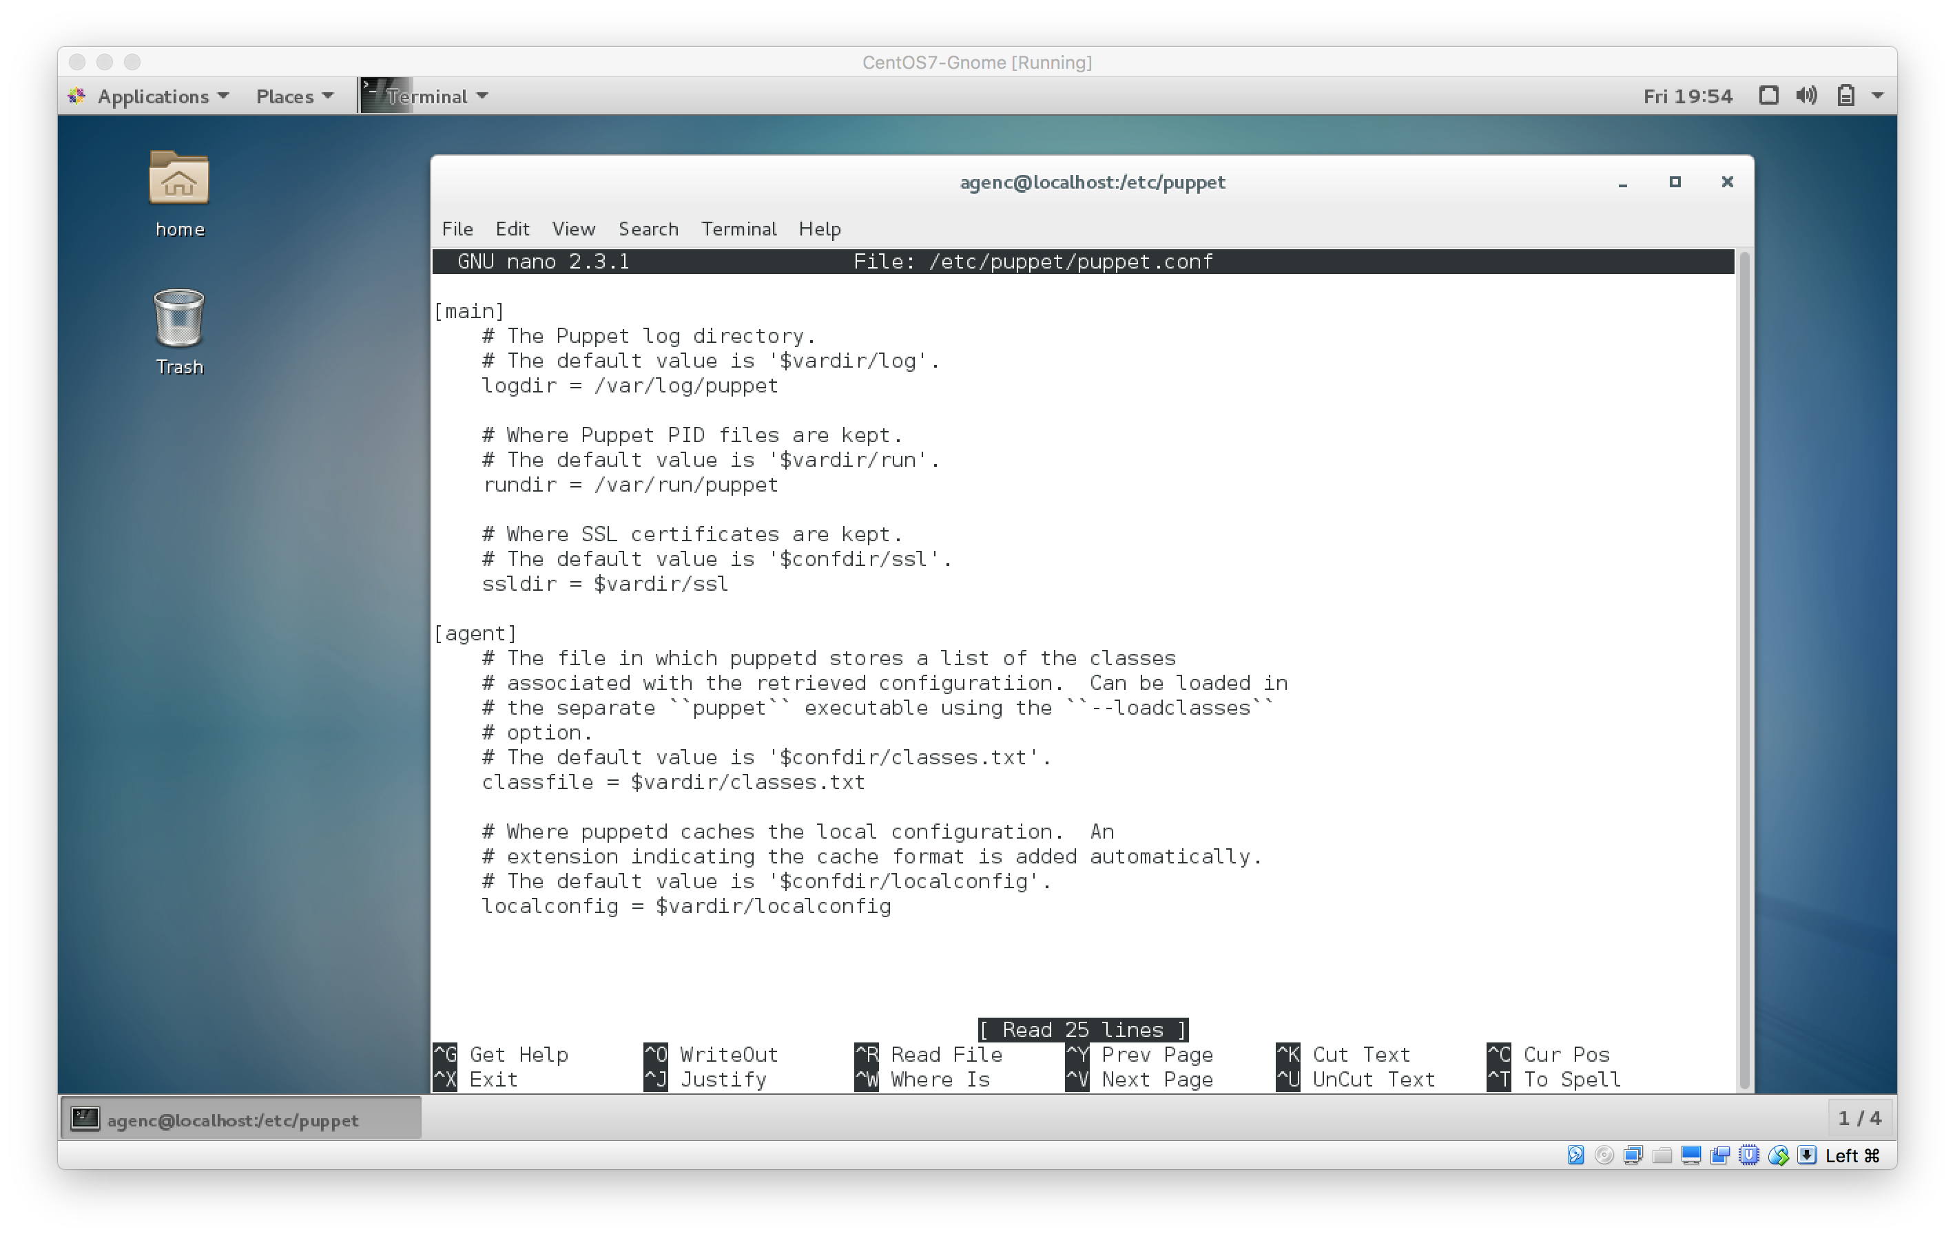

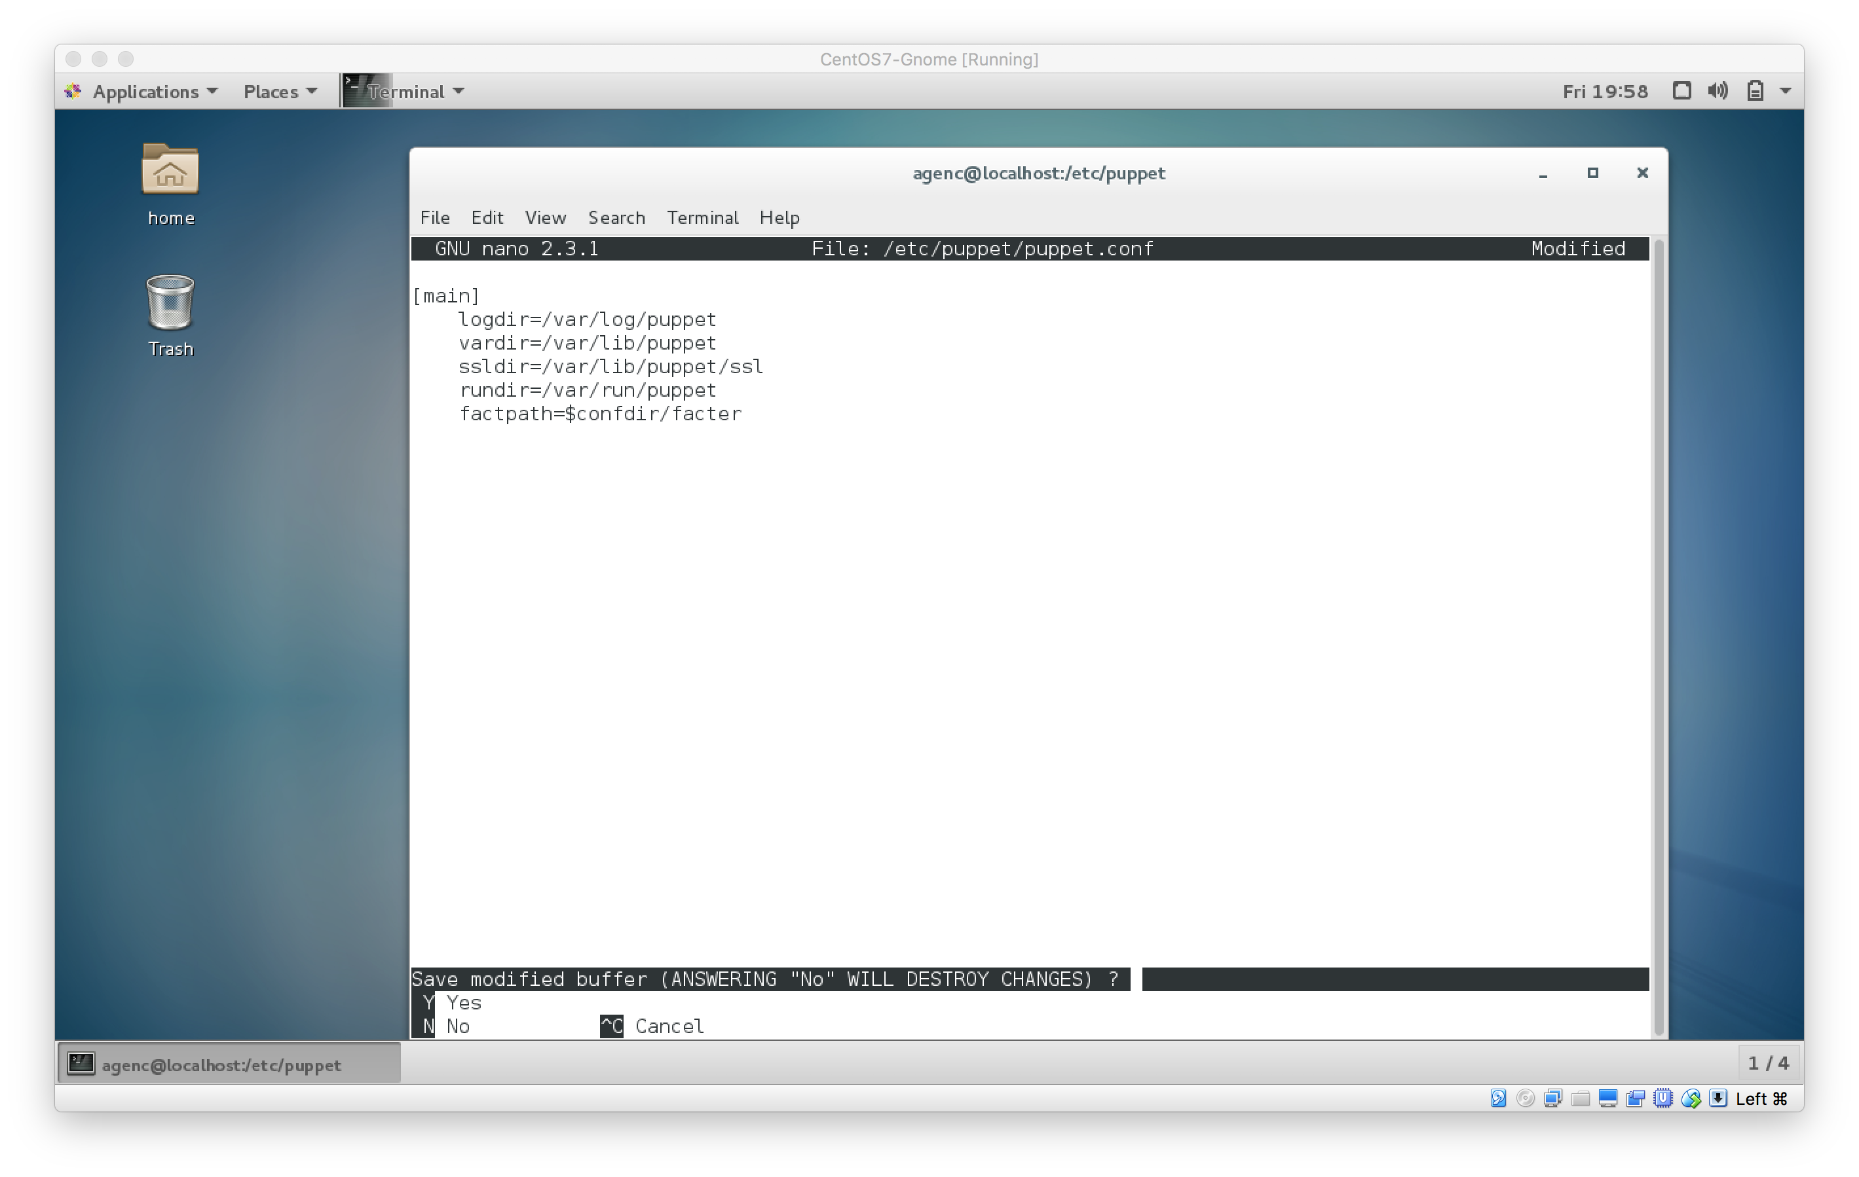

Step 6 — Adding a Puppet Module

Now Puppet is set up, but it's not doing any work. The way Puppet works is by looking at files called manifests that define what it should do, so in this step, we'll create a useful module for Puppet to run.

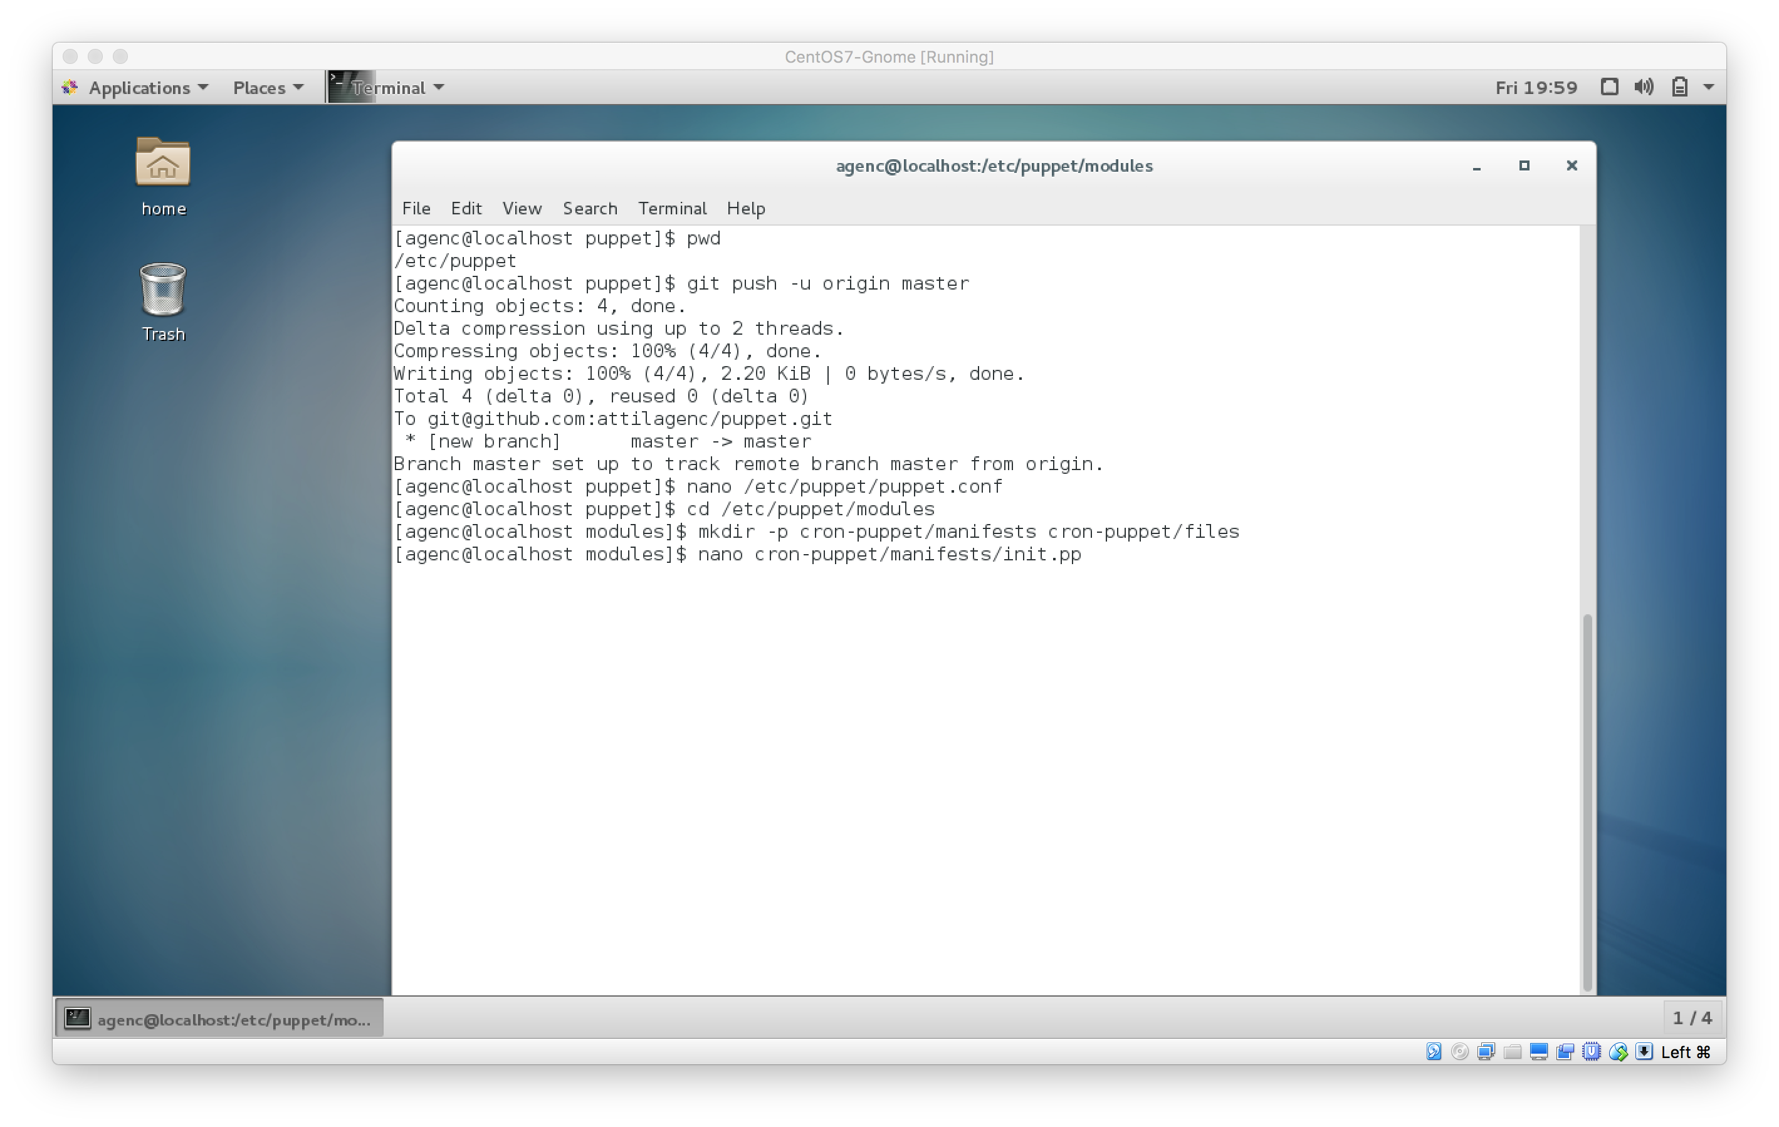

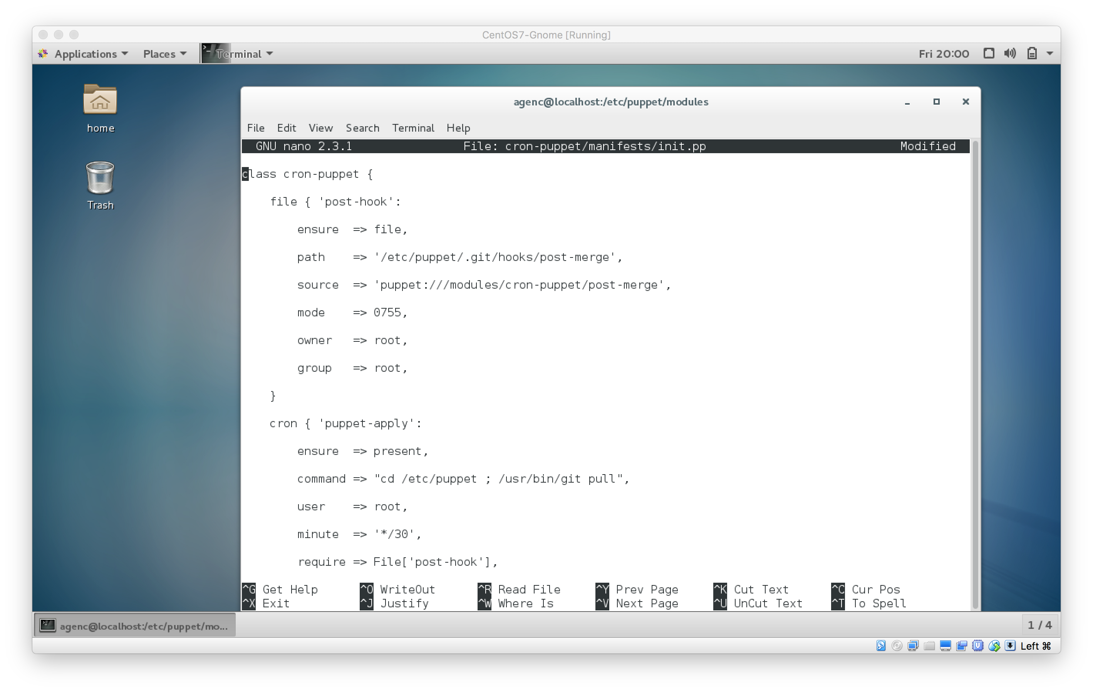

Copy the following bash script into post-merge. This bash script will run after a successful Git merge, and logs the result of the run.

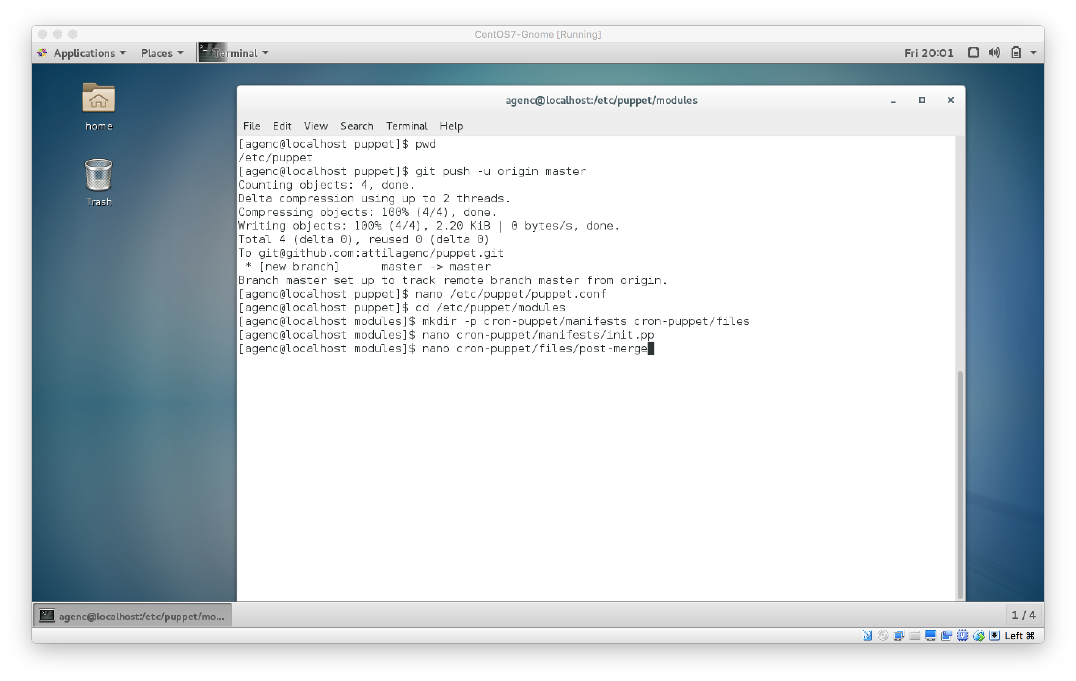

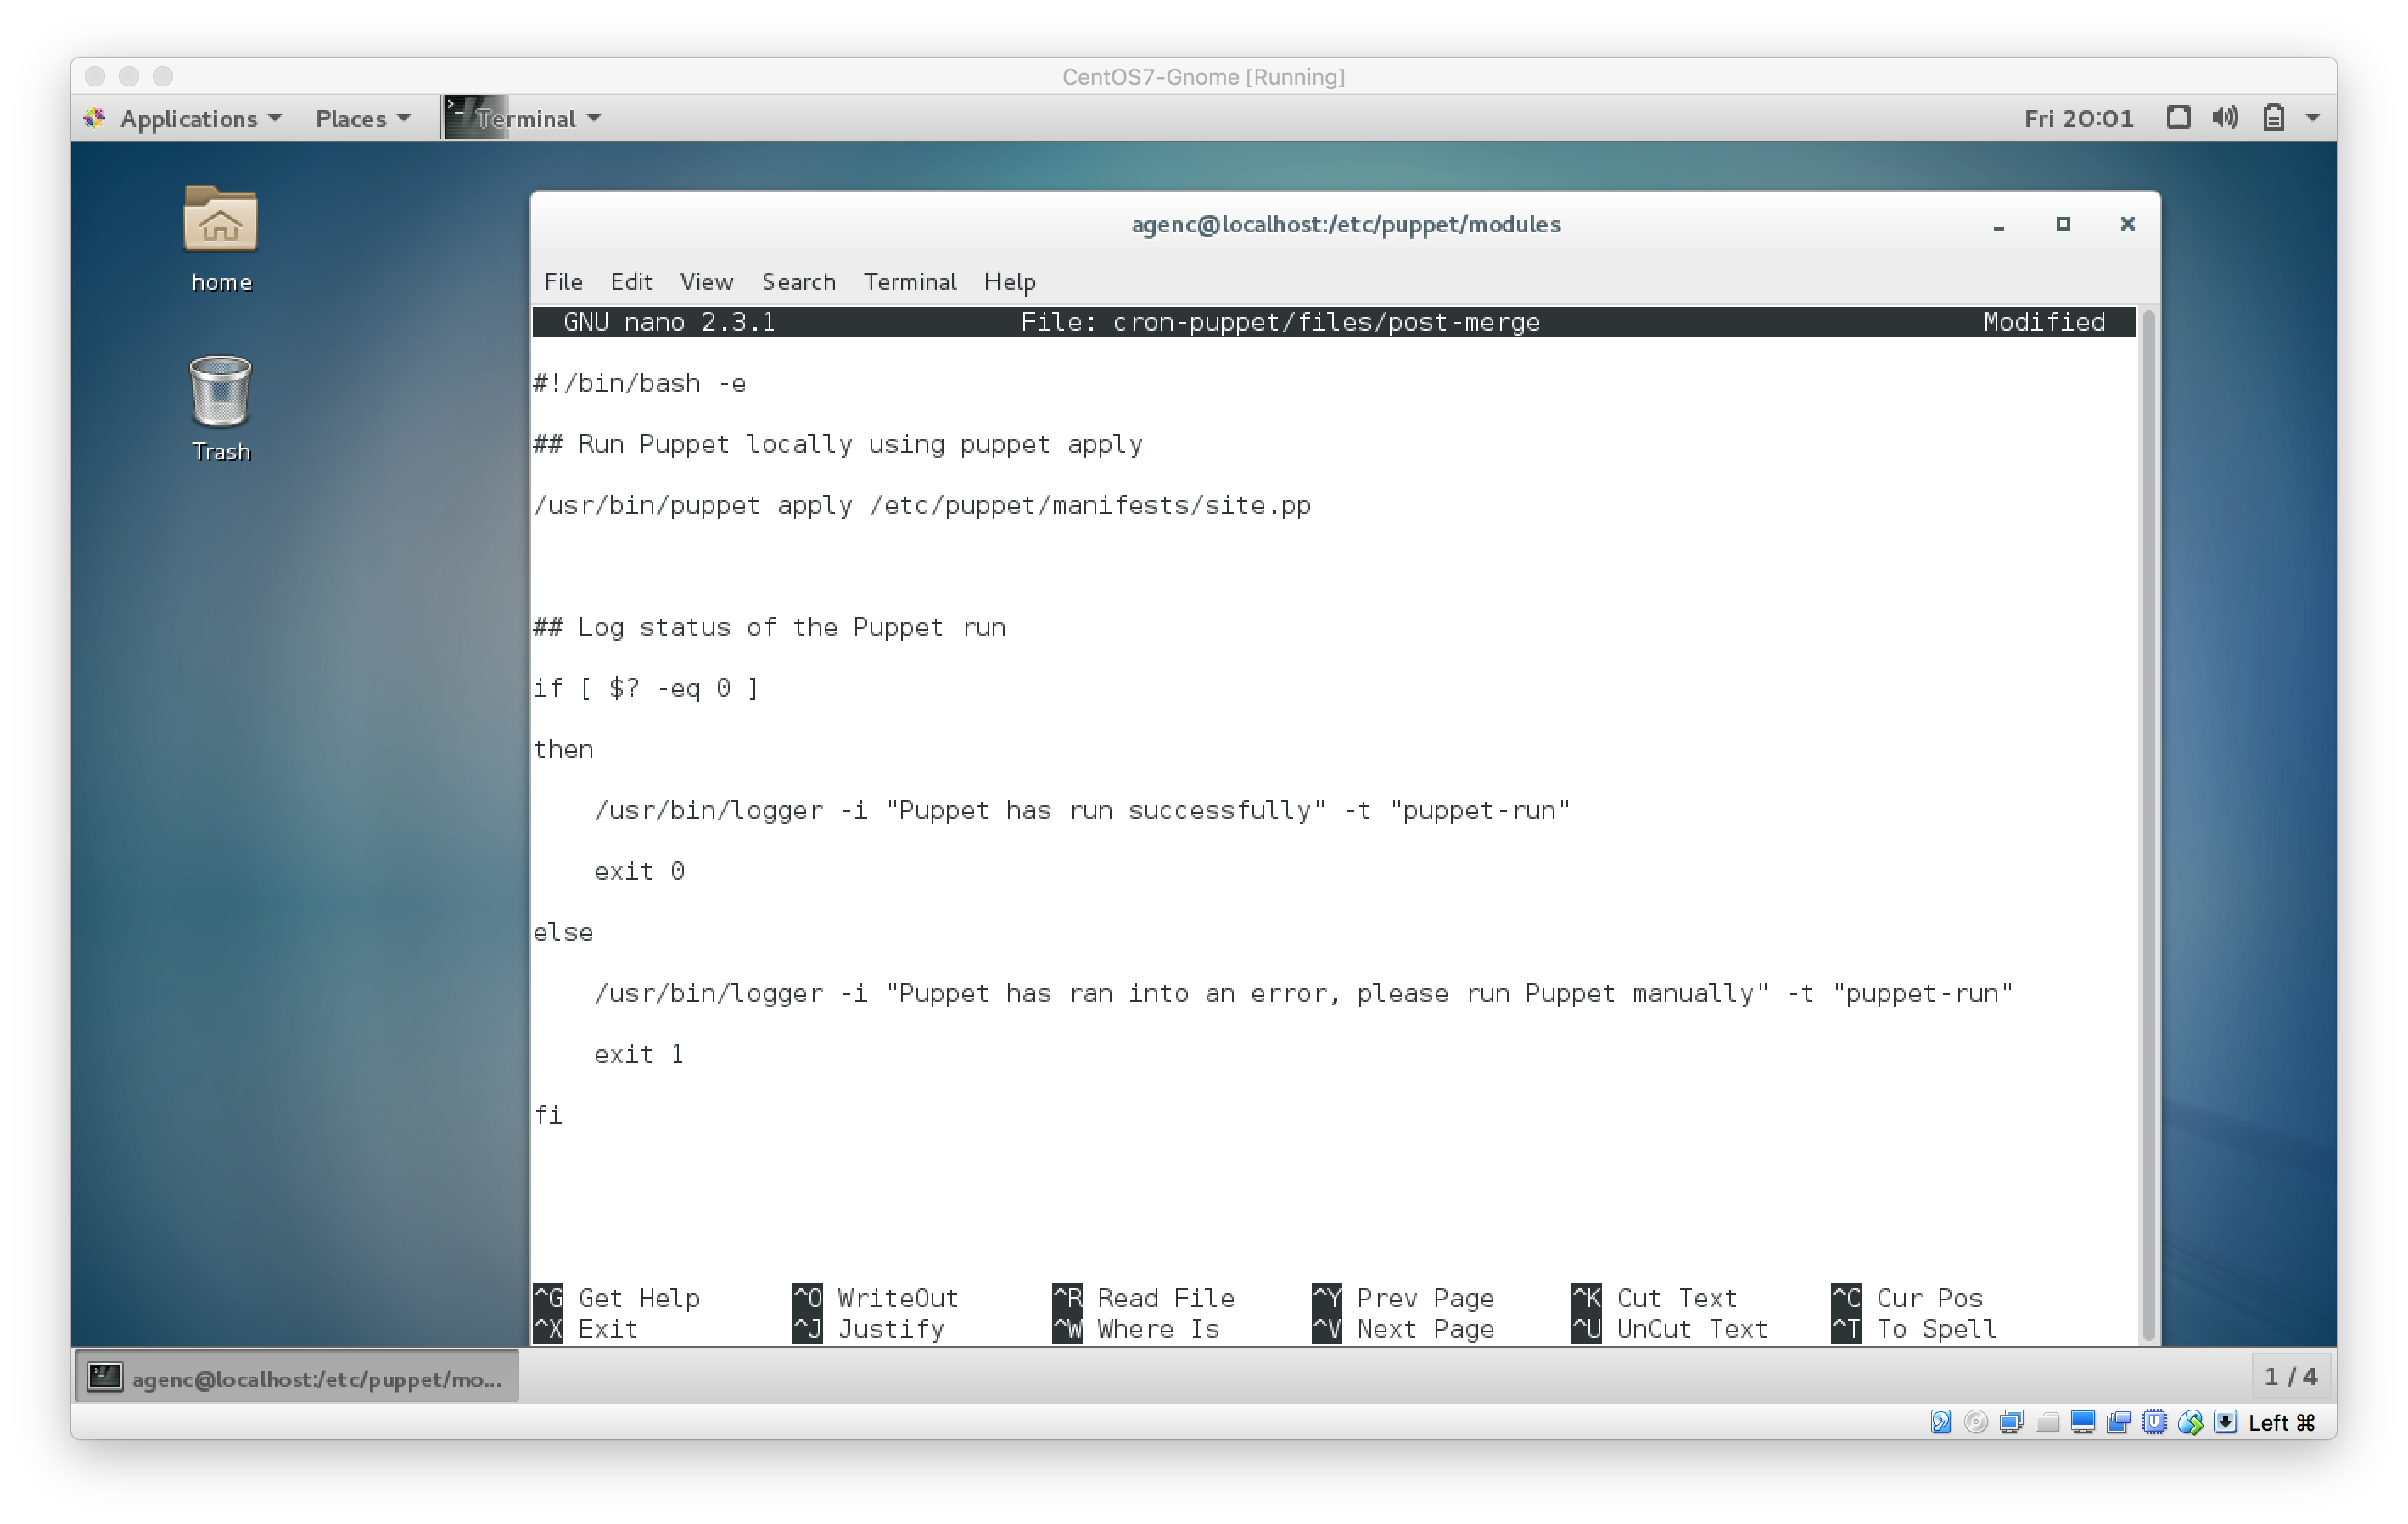

Finally, we have to tell Puppet to run this module by creating a global manifest, which is canonically found at /etc/puppet/manifests/site.pp.

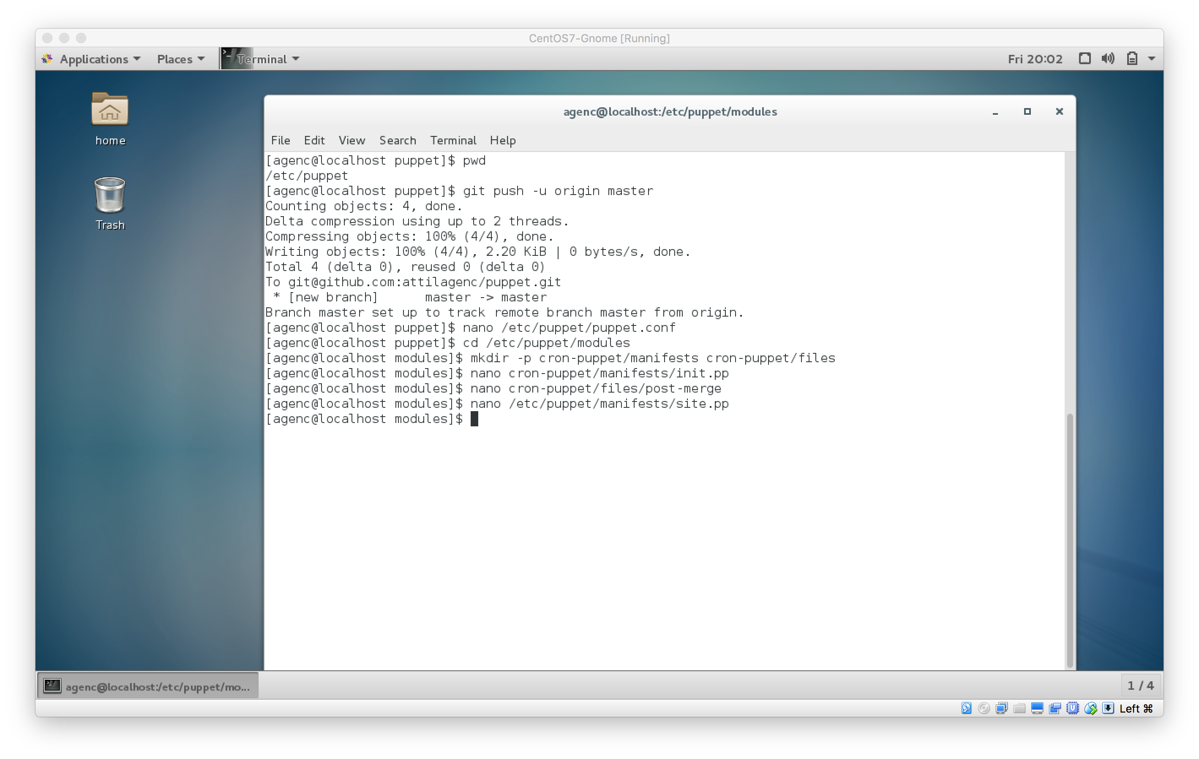

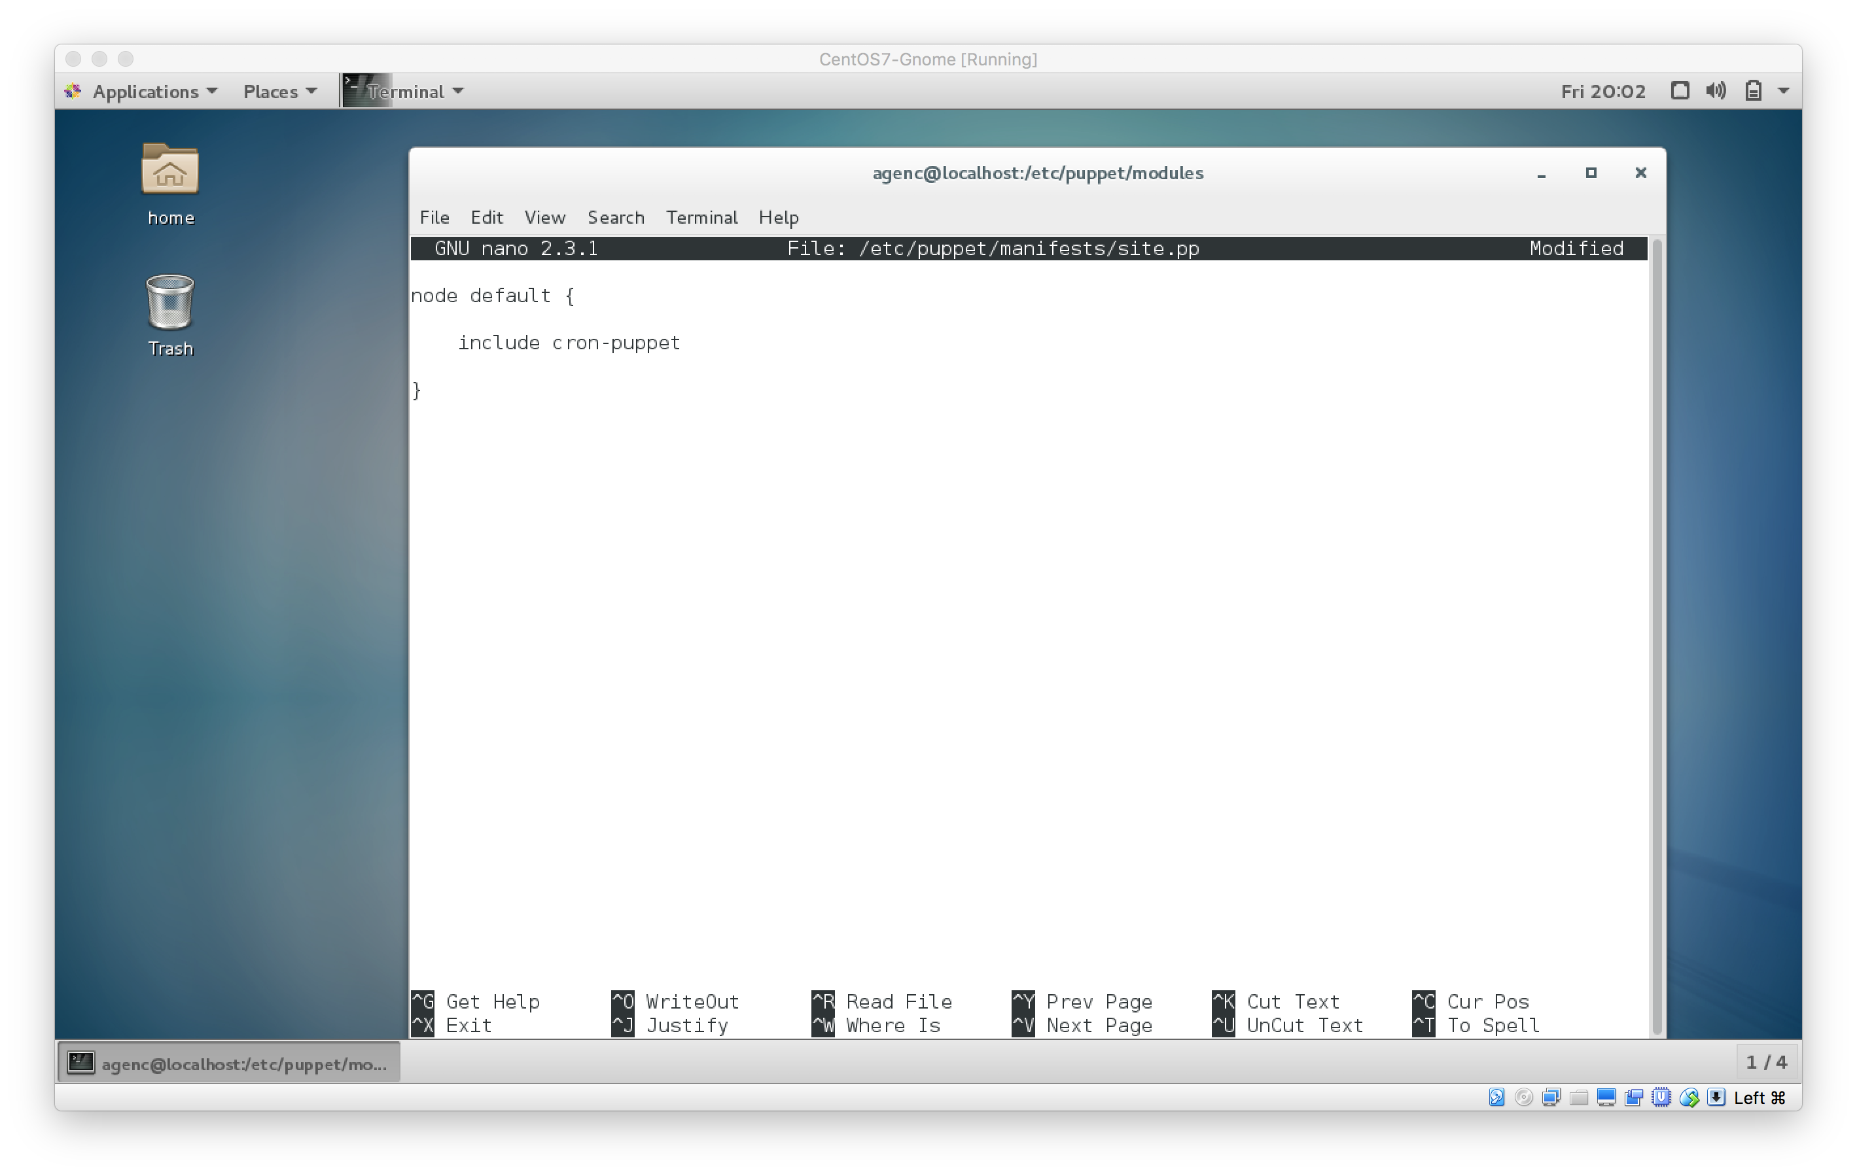

Save and close the file. Now, let's make sure our module works by running it.

After a successful run you should see some output ending with a line like this.

...

Notice: Finished catalog run in 0.18 seconds

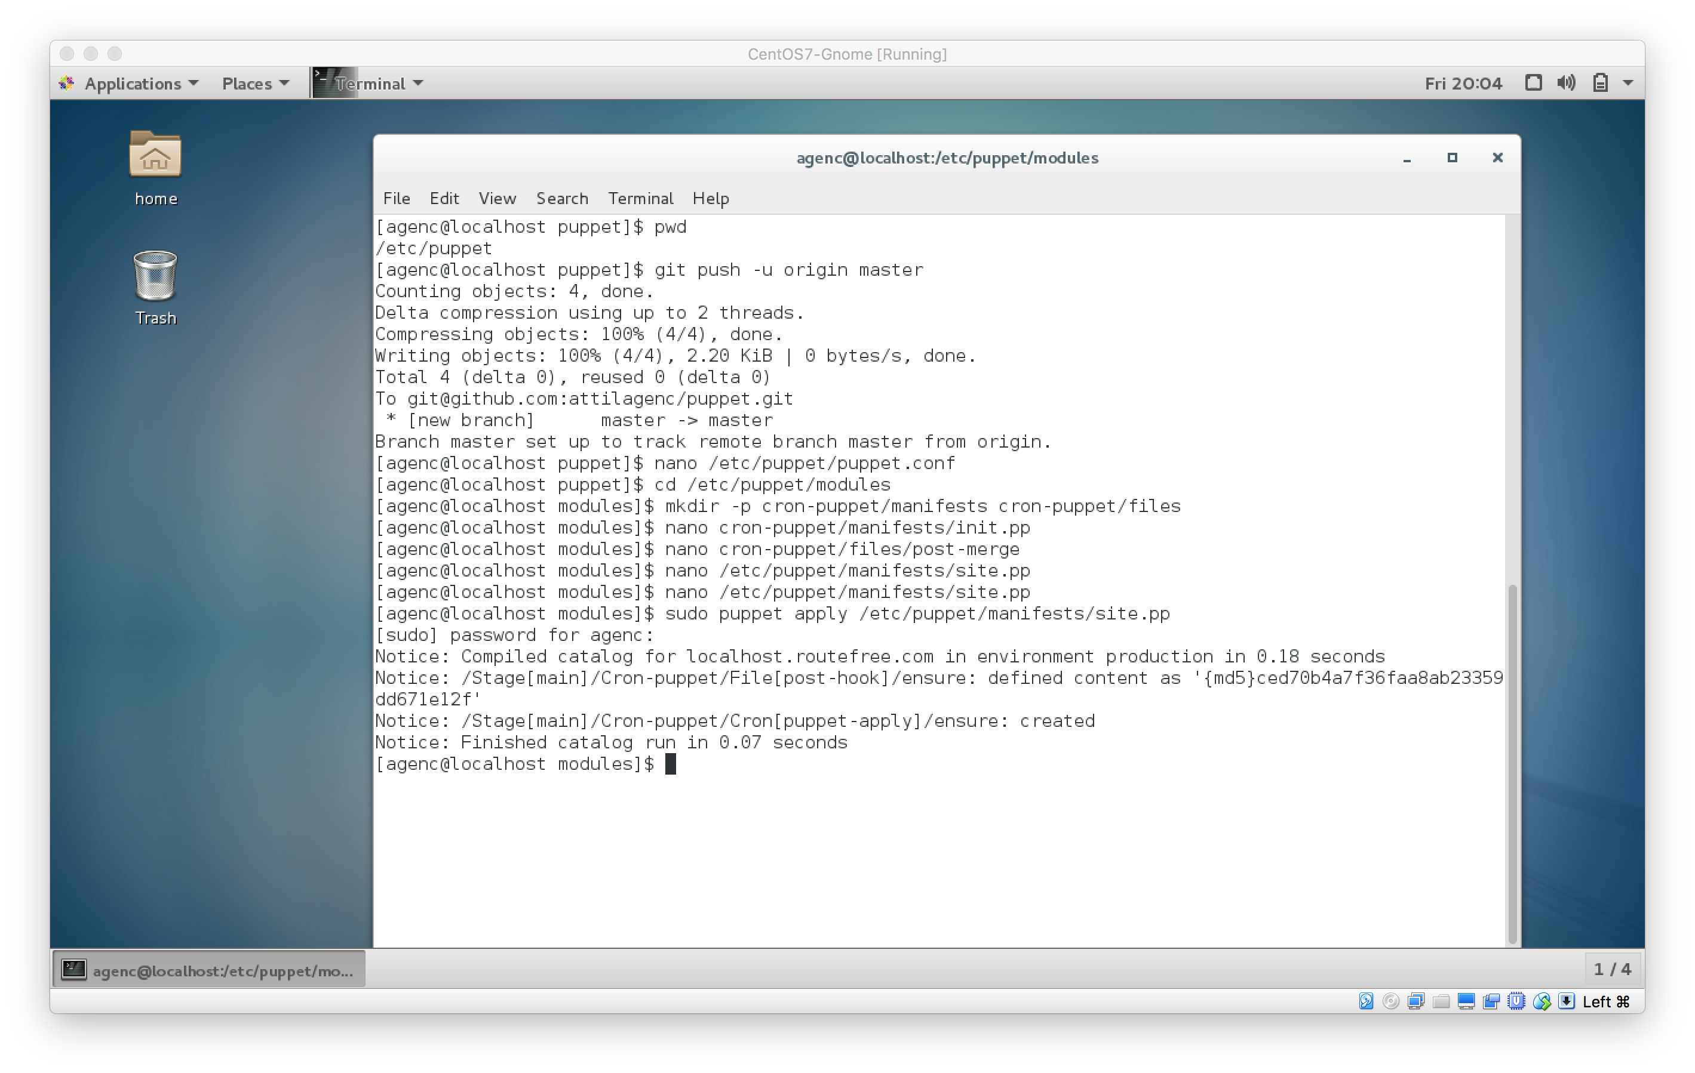

Finally, let's commit our changes to the Git repository. First, log in as the root user, because that is the user with SSH key access to the repository.

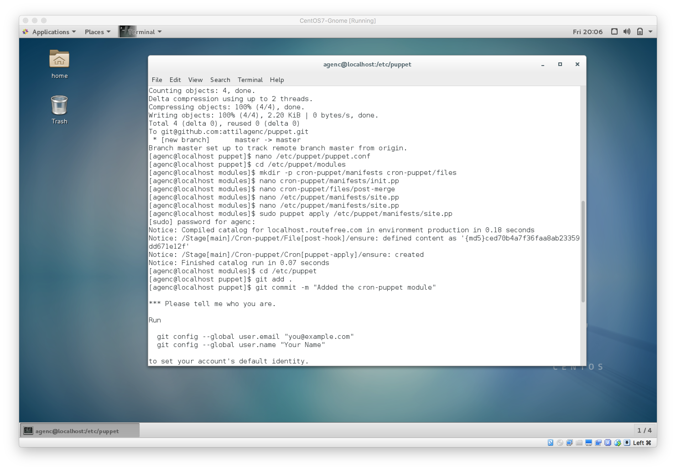

Finally, push the changes.

* git push -u origin master

